**SQLRPGLE ASSIGNMENT (25.01.2025)**

1. Create vendorsql table with vendor name , vendor number , vendor address as  fields , vendor no should be primary key .

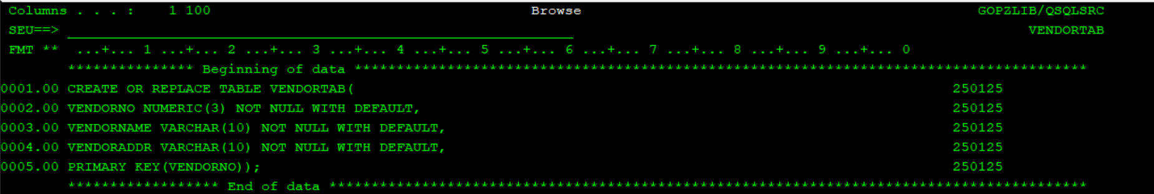

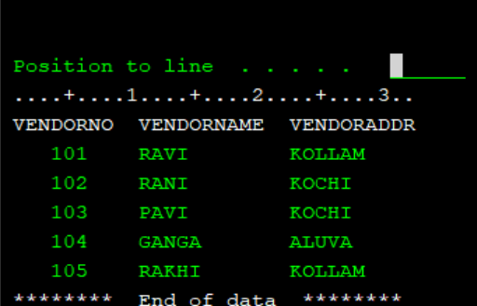

1. Create order header table with order no ,  vendor number, order date , order value as flds (order no should be primary key).  and vendor number should be foreign key referring vendor table.

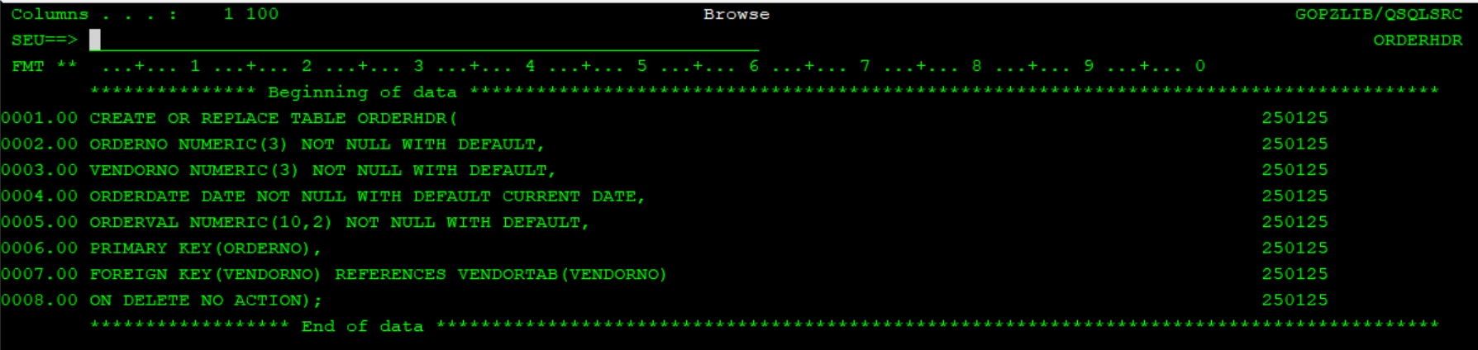

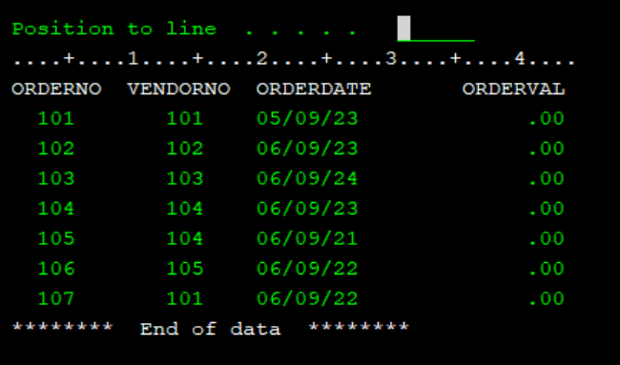

1. Create order detail table with order no , item no , qty , per item price as flds

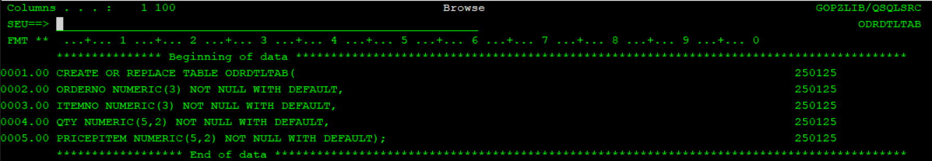

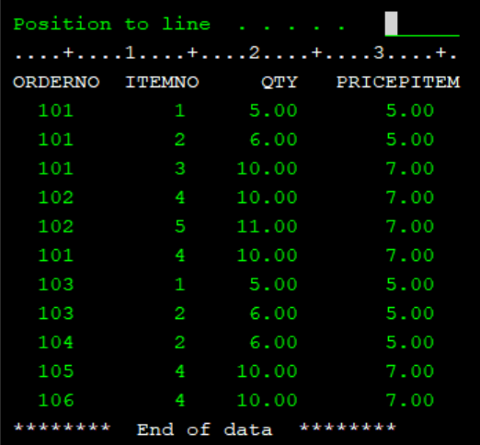

1. ceate sqlrpgle program to populate order value field in order header table by taking input from order detail

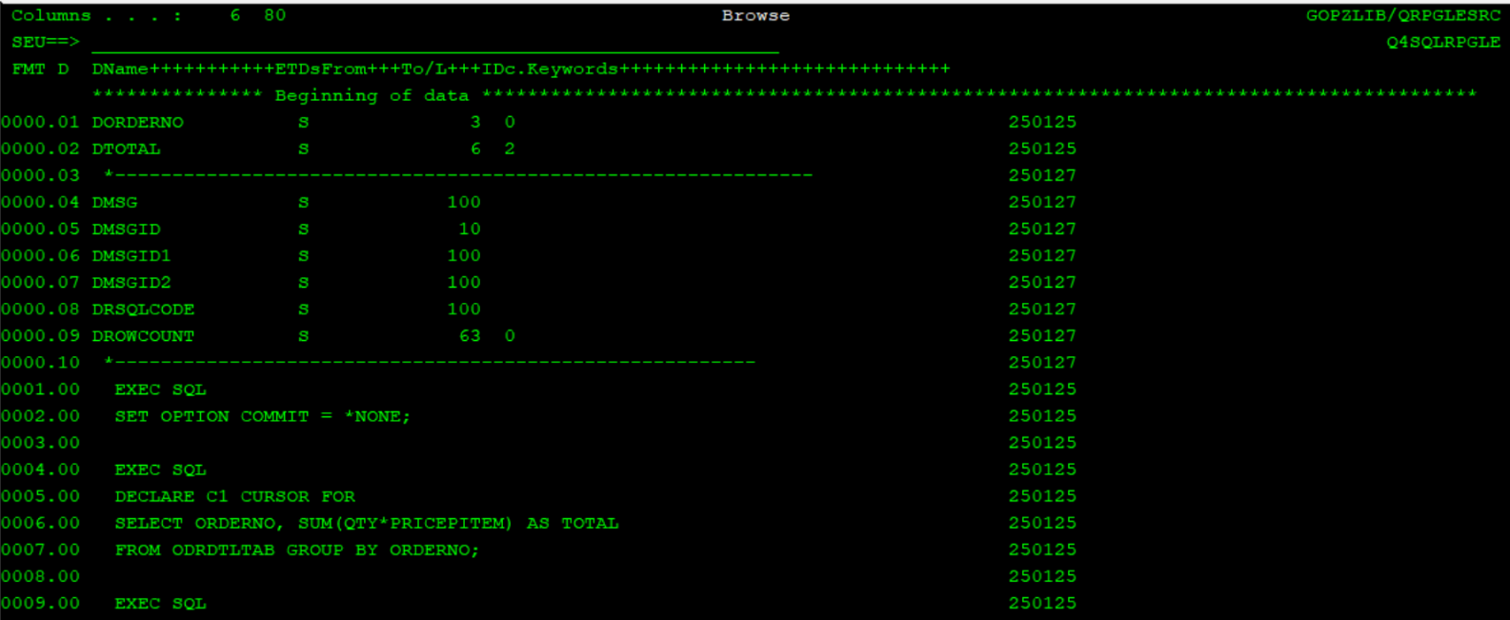

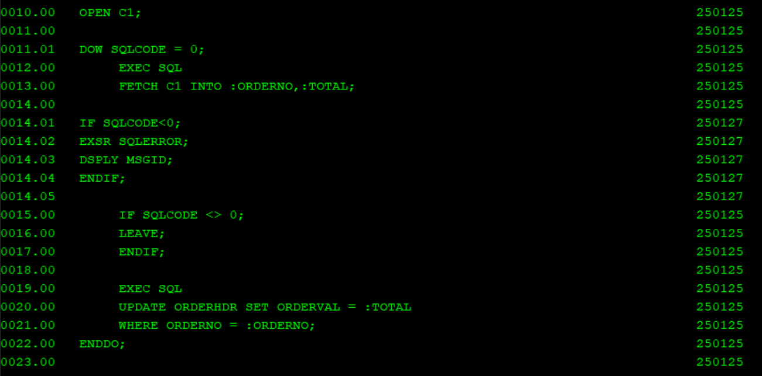

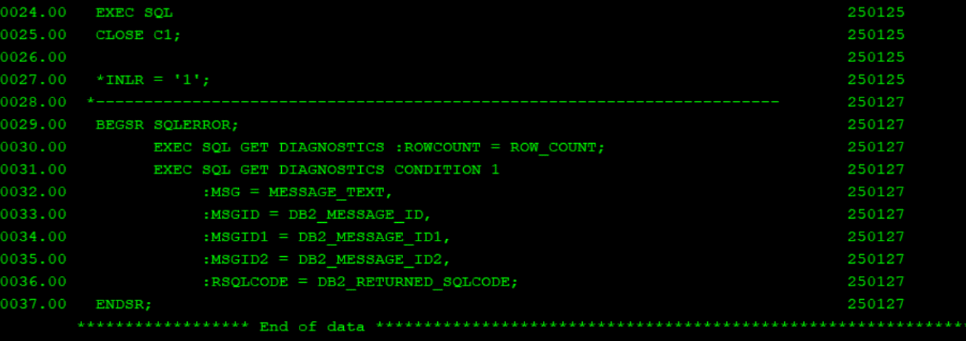

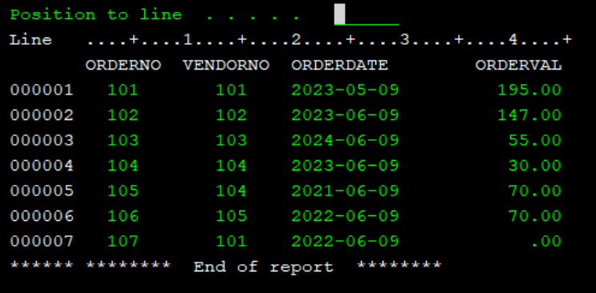

1. Create sqlrpgle program to display order no , vendor number , item no , quantity and per item price fields in subfile . take input as order date from other record format, add functionality to sort based on field heading.

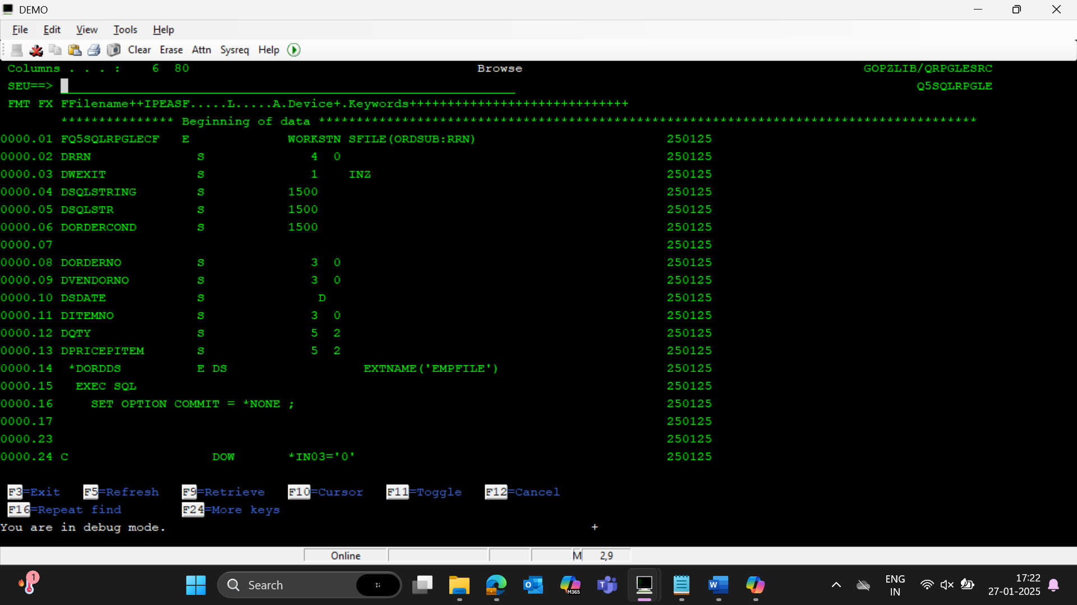

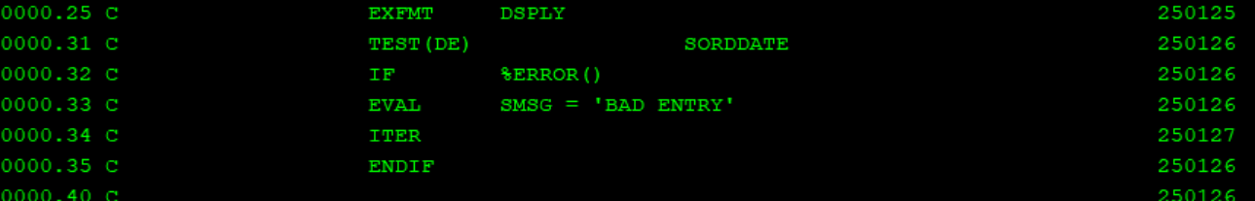

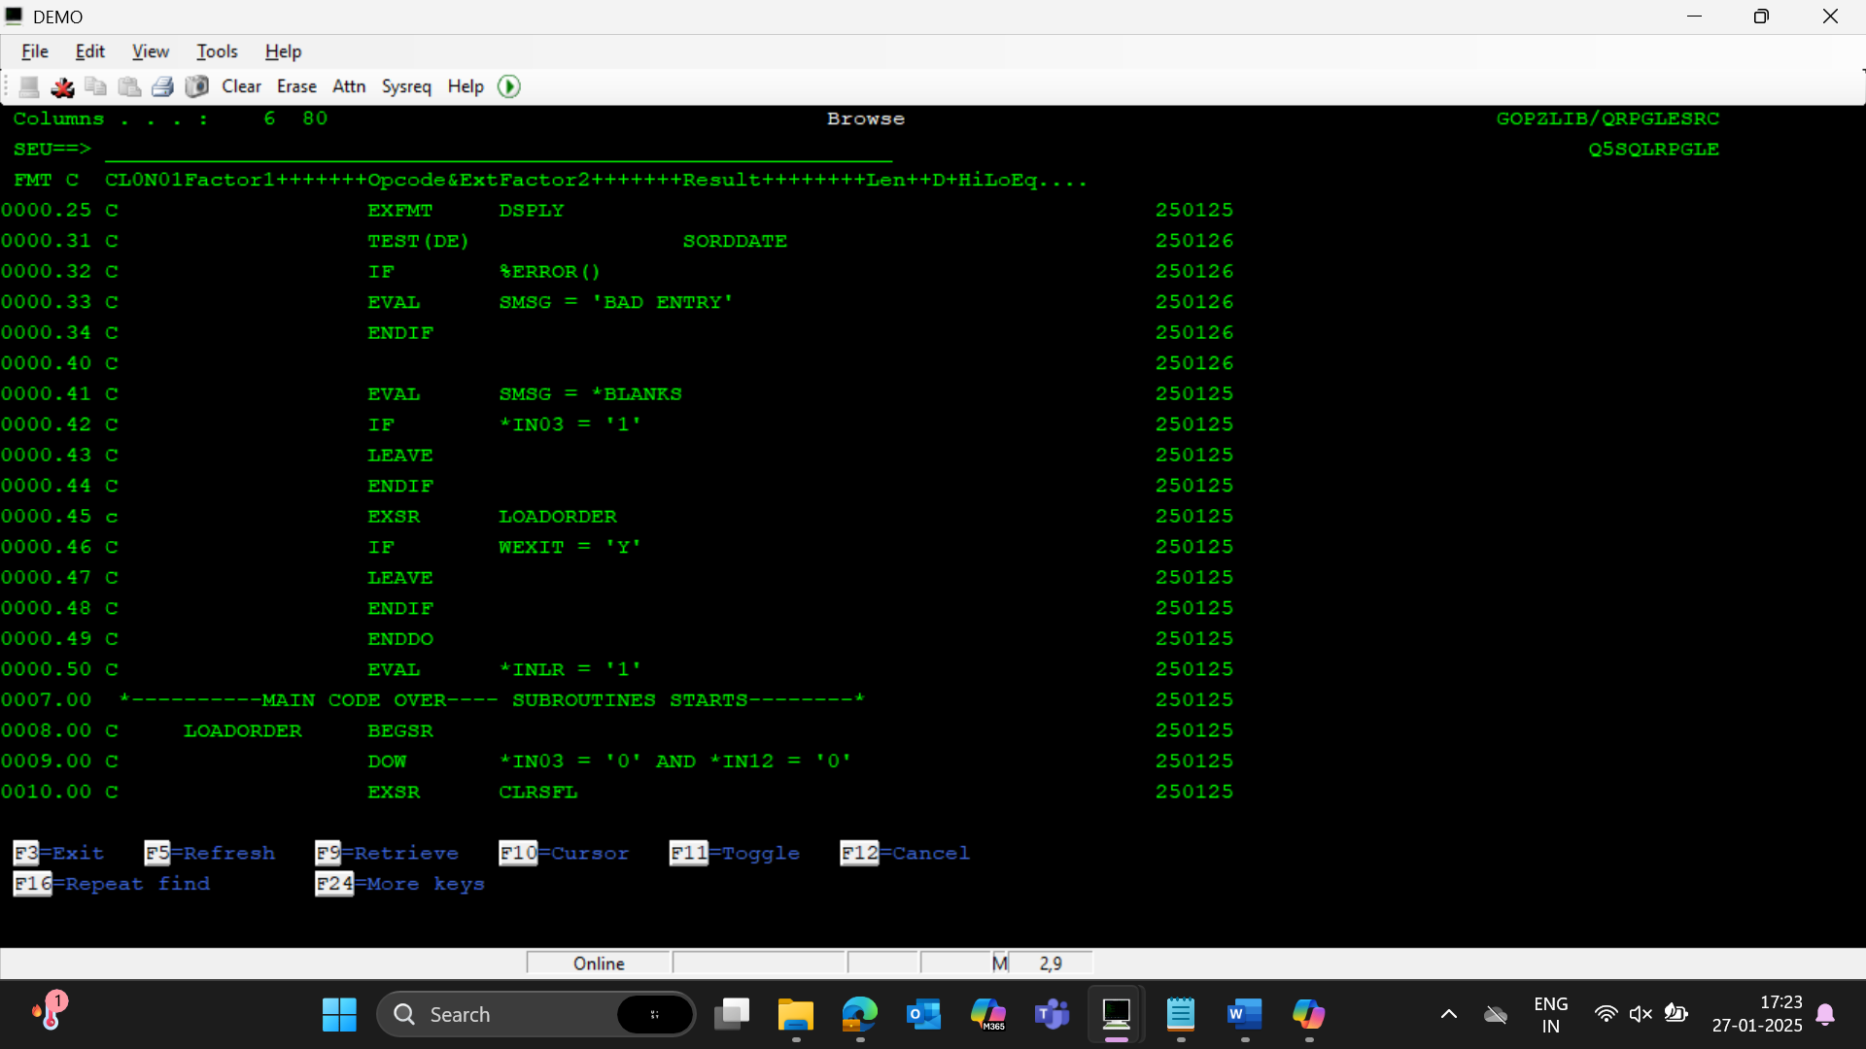

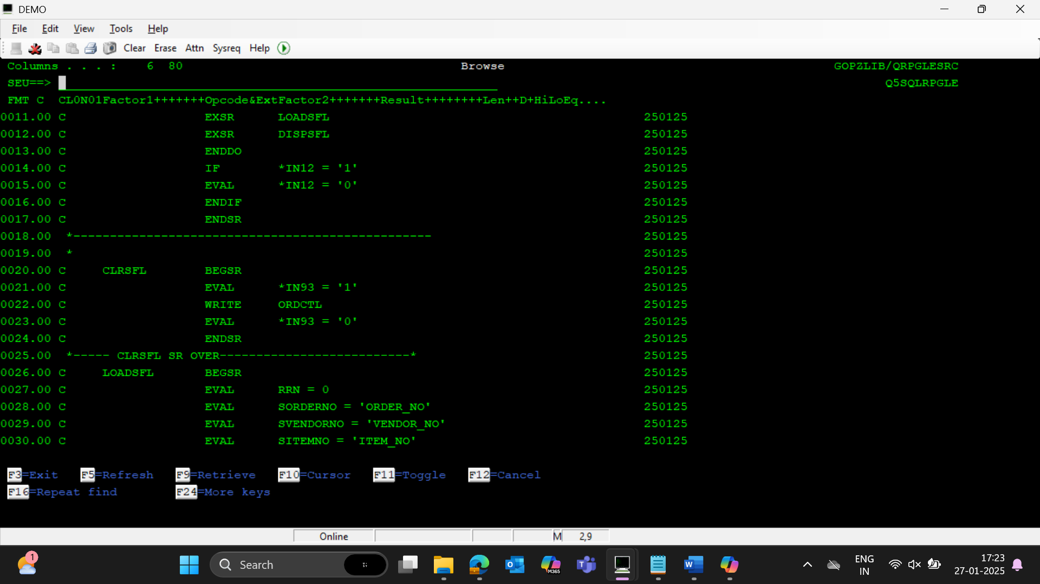

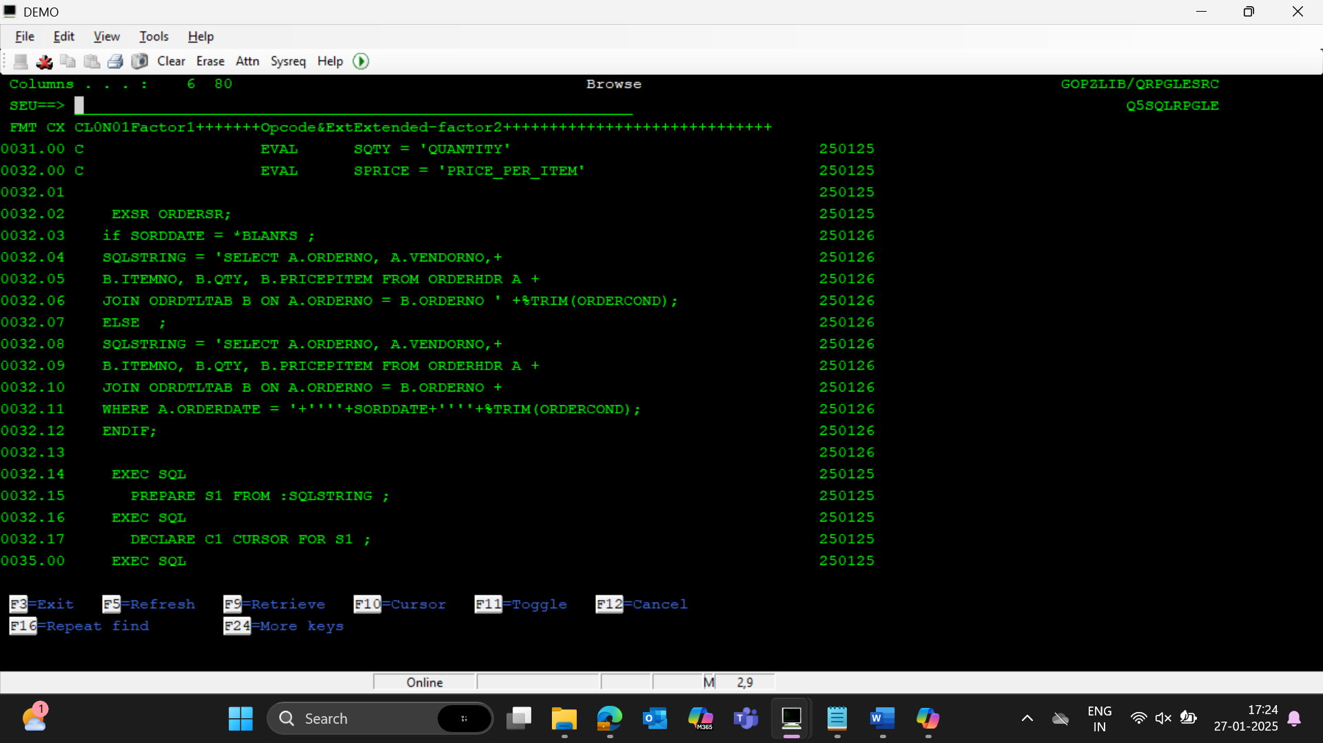

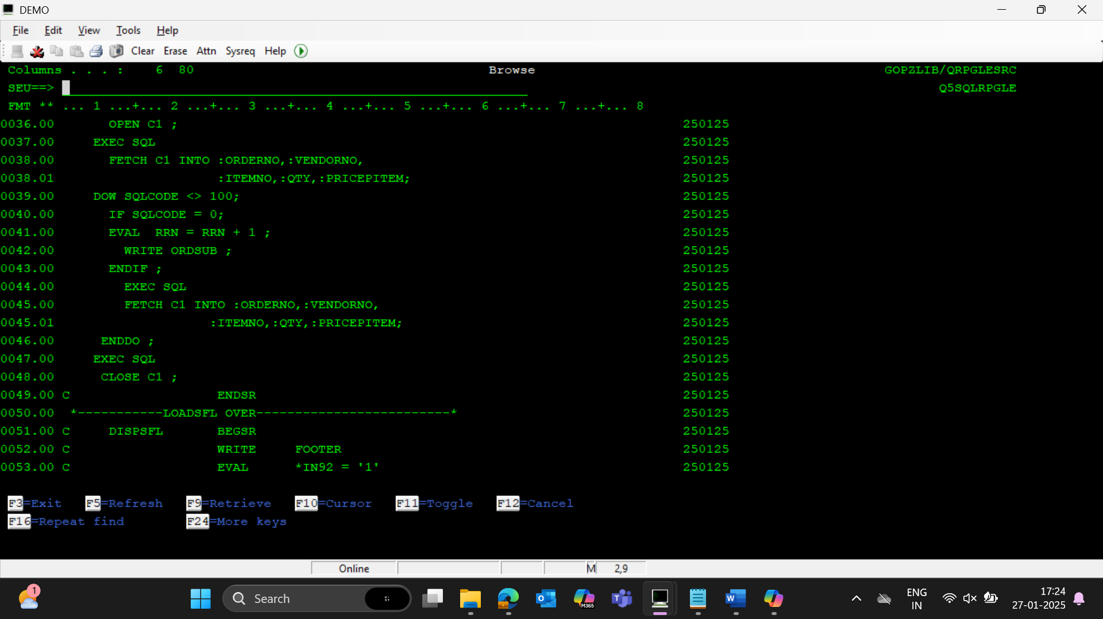

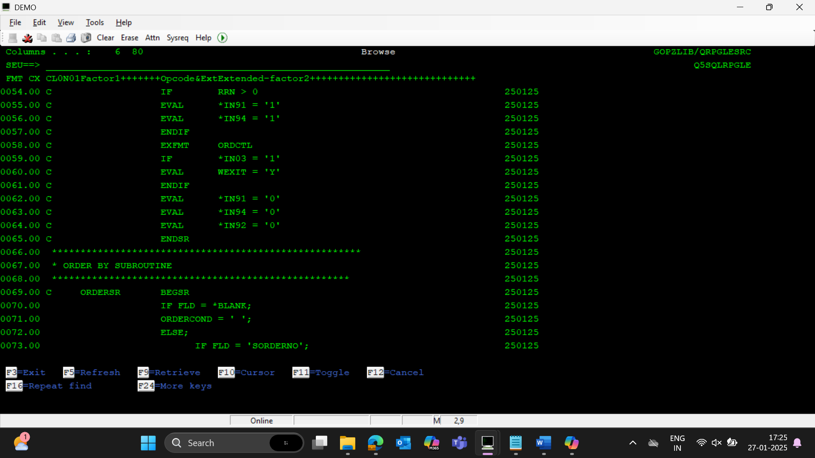

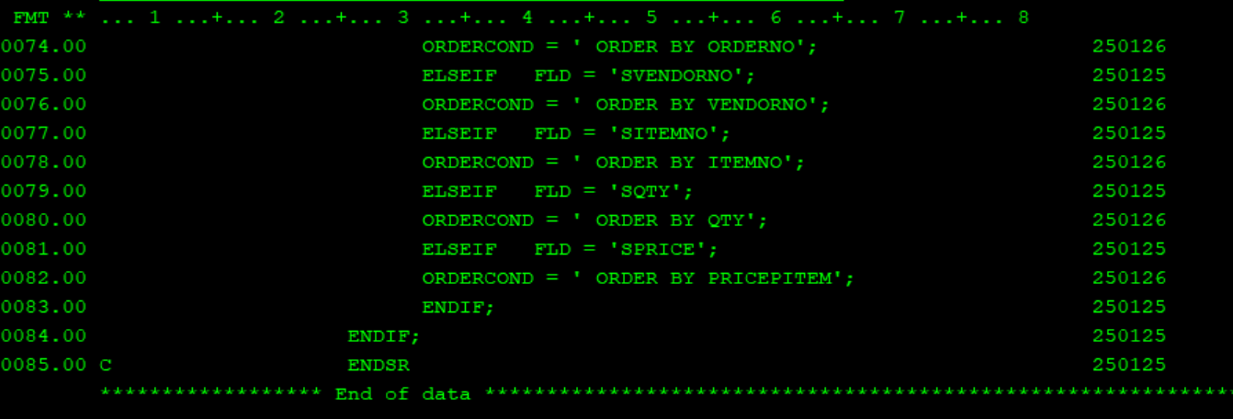

1. Create sqlrpgle program to generate report by taking vendor number as input , display vendor name at header and detail should list all orders for that vendor with field order number , item number , order date and order value and footer should display total order value for that vendor

Use view in this.

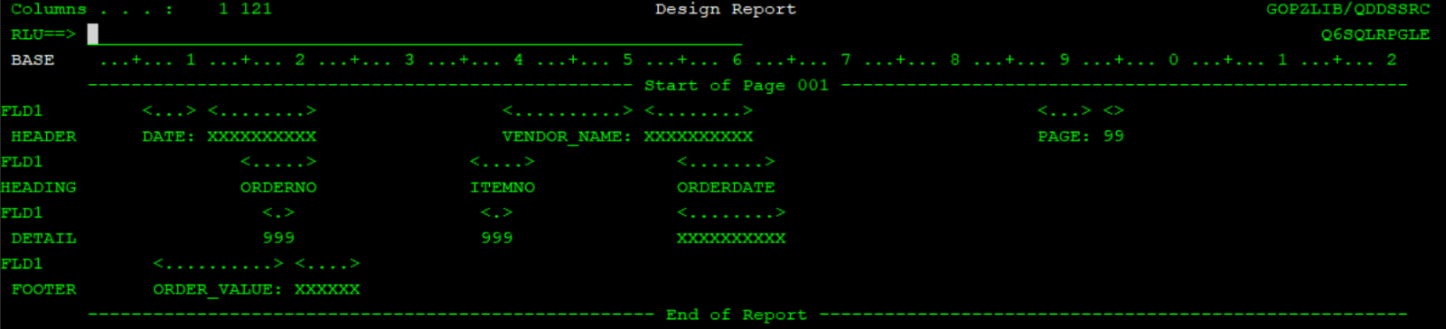

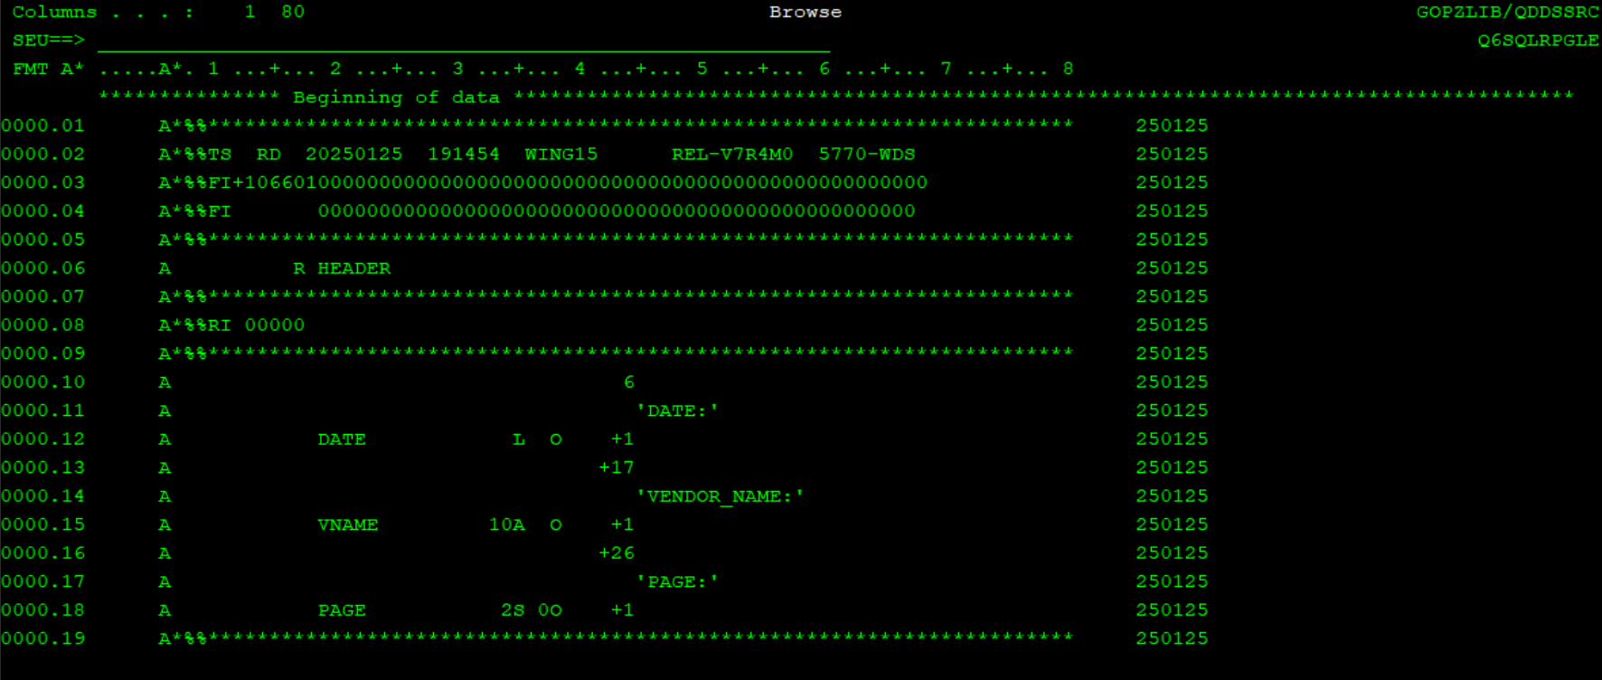

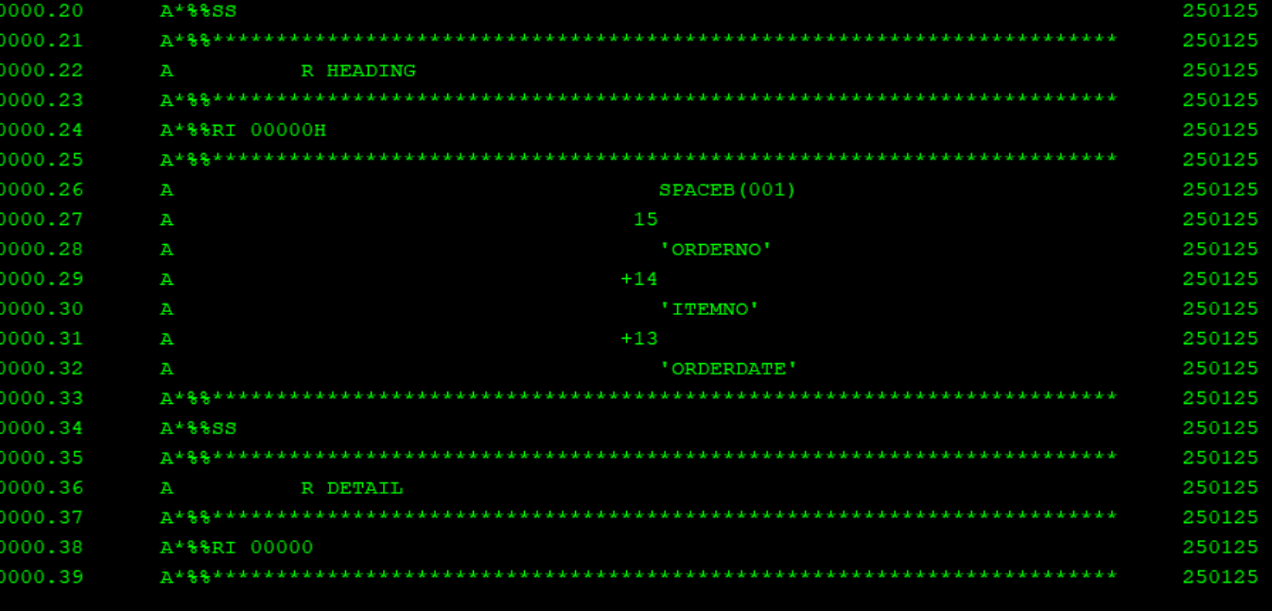

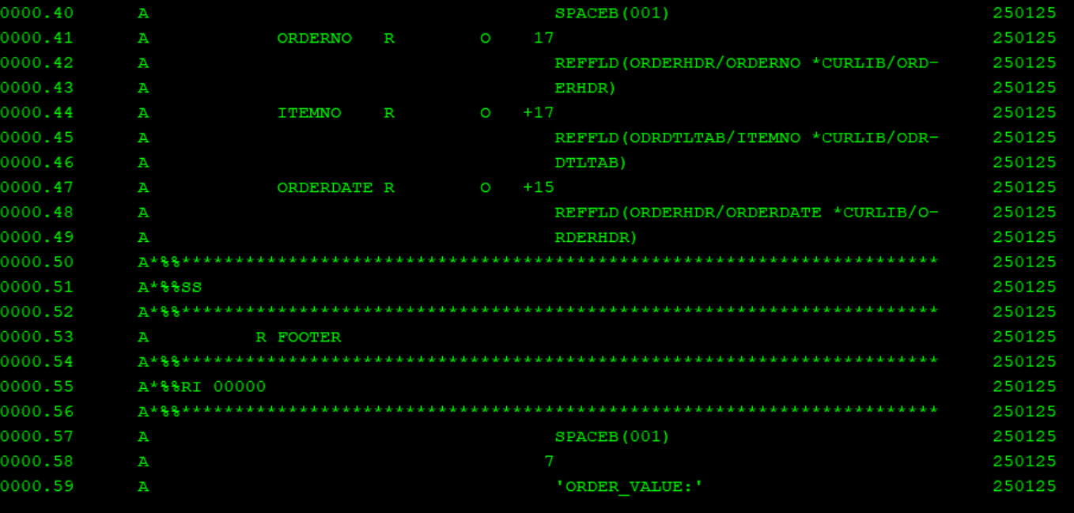

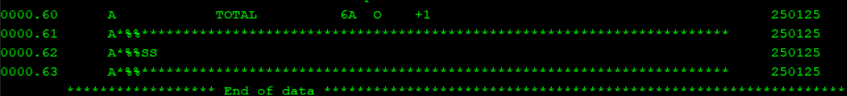

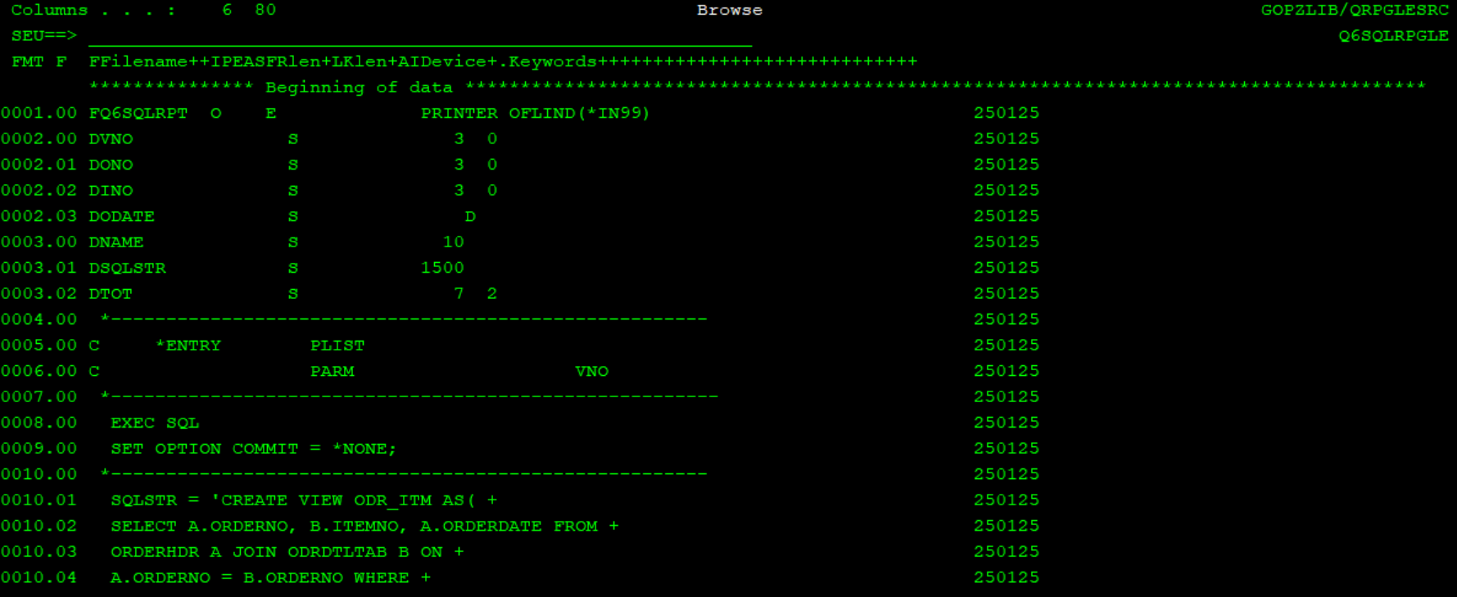

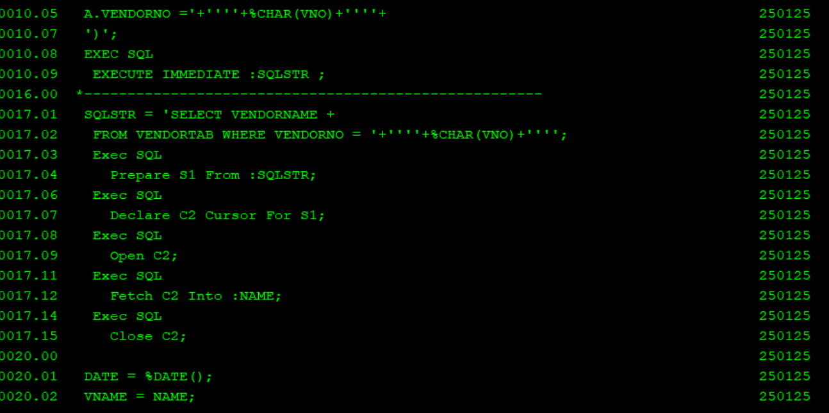

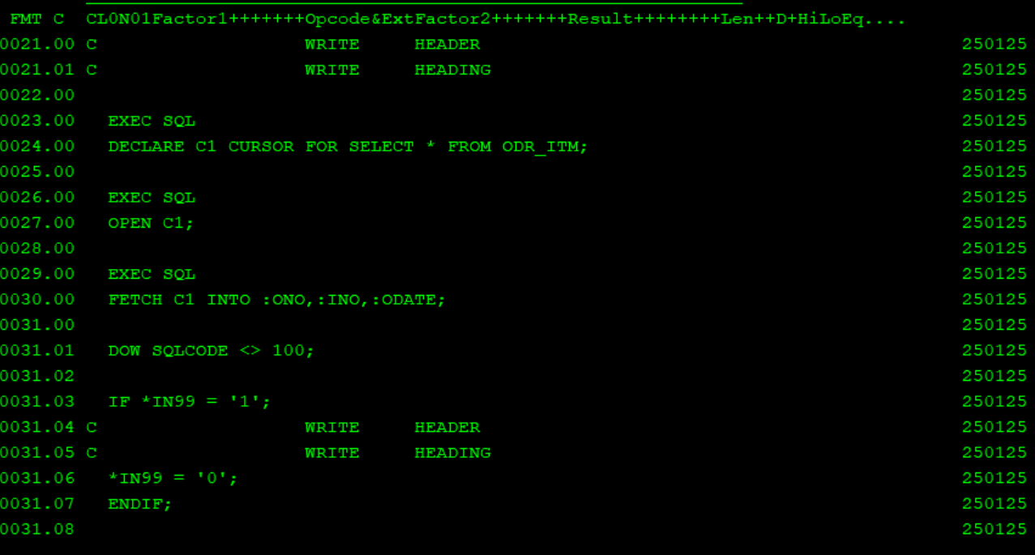

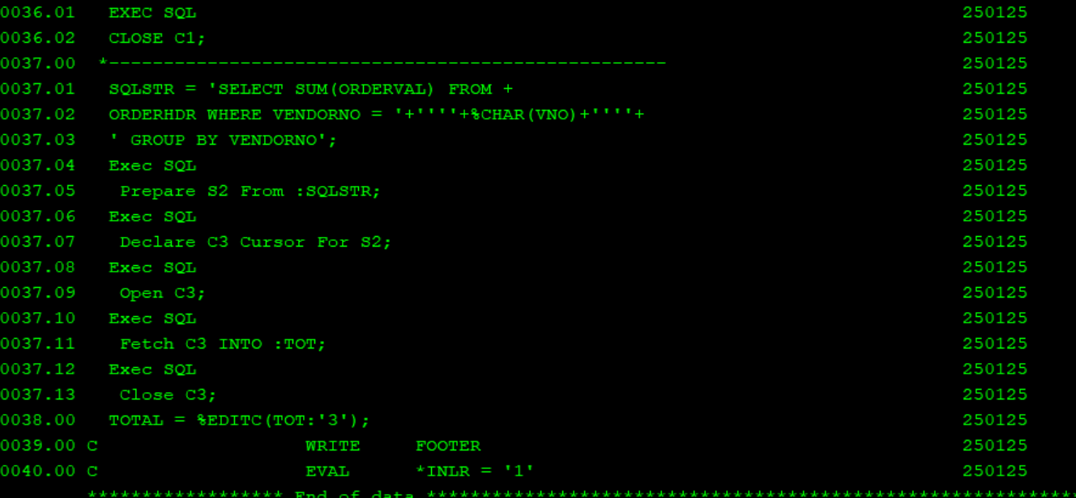

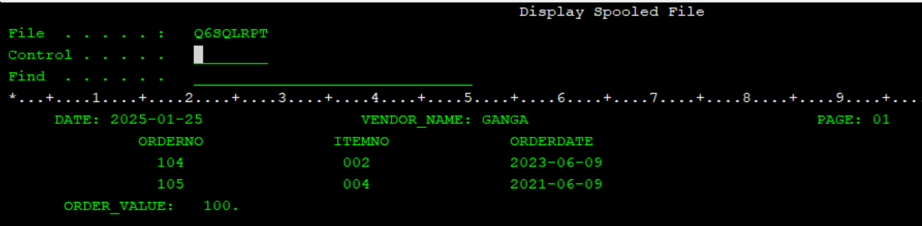

1. create sqlrpgle program to print all order details where values is more than 10000 and for input vendor. Checking for order values and vendor validation should be done through ILE procedures which will return either 0 or 1 based on input validation , add both procedures in same module .

*ALSO USED SQL DIAGNOSTICS

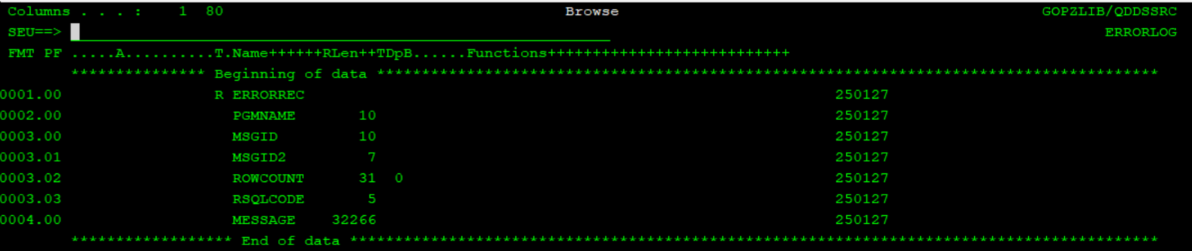

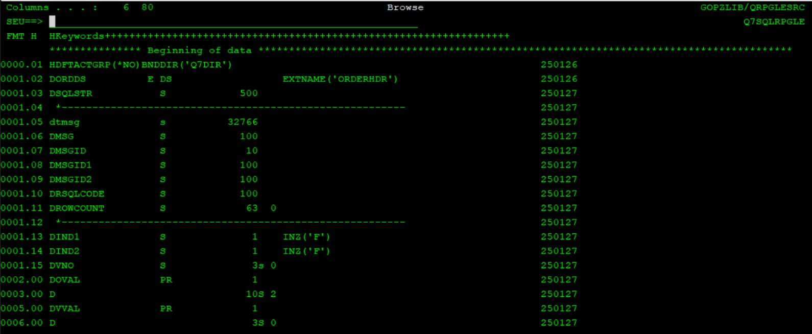



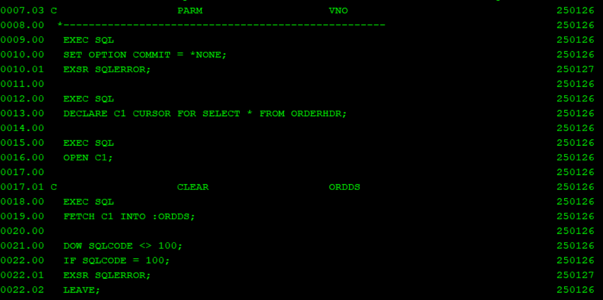

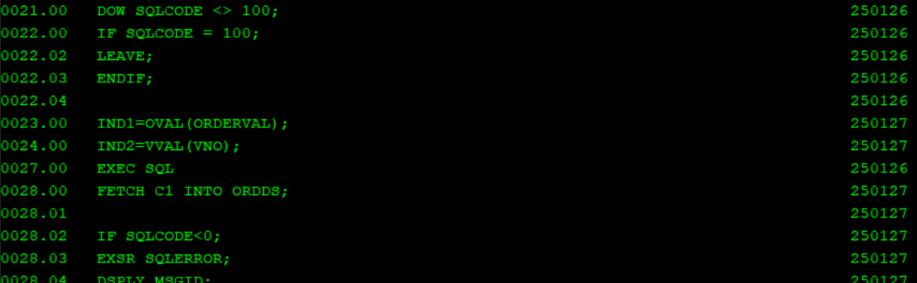

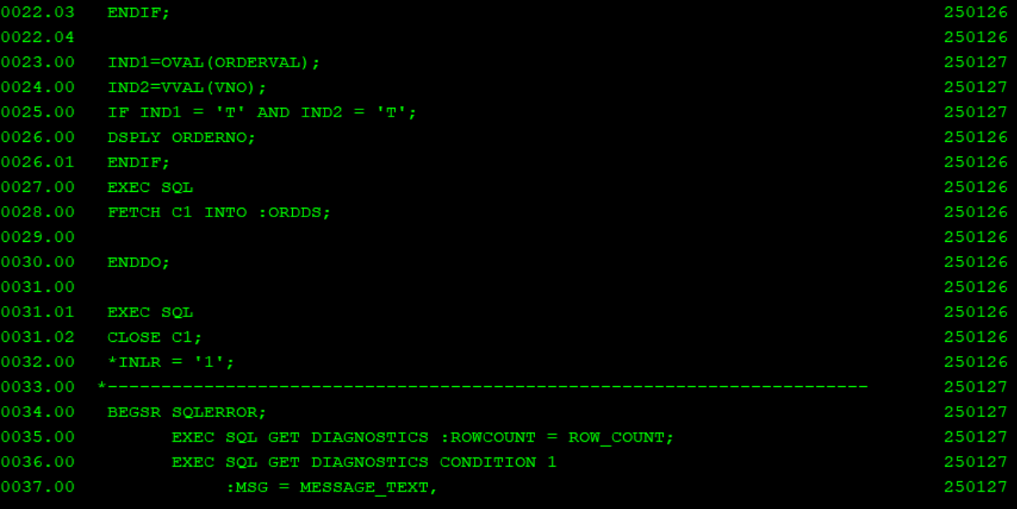

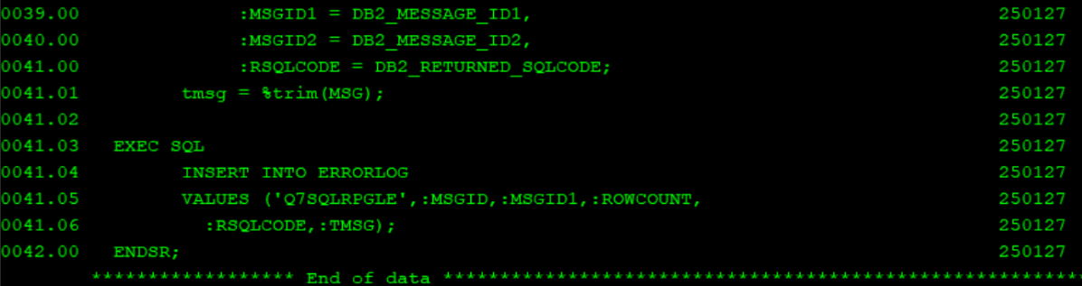

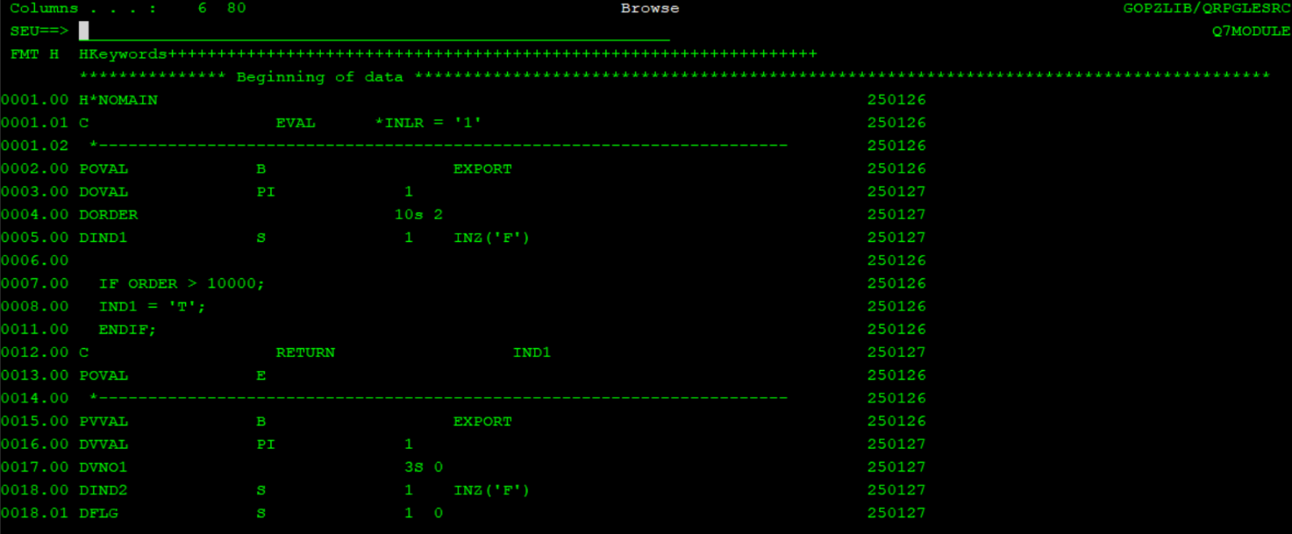

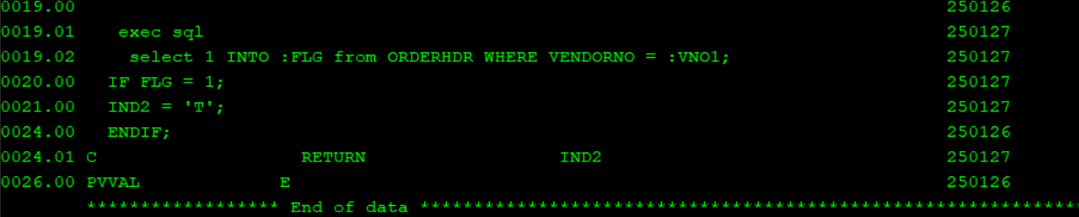

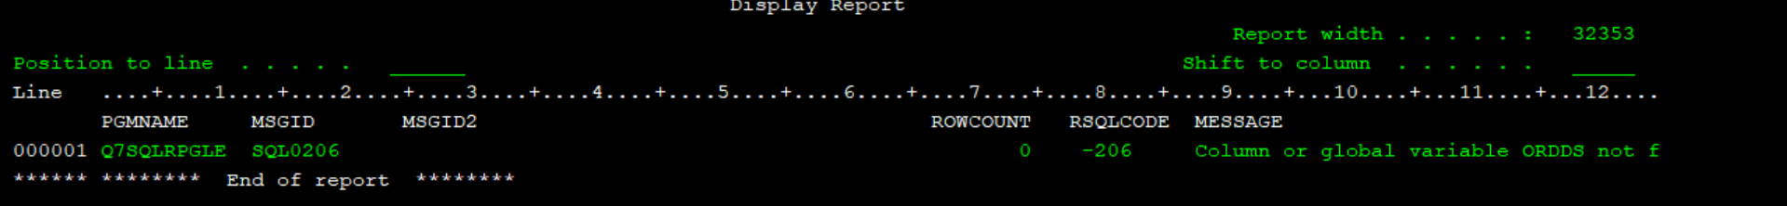

Library name : GOPZLIB

1. QSQLSRC/VENDORTAB
2. QSQLSRC/OREDRHDR
3. QSQLSRC/ODRDTLTAB
4. QRPGLESRC/Q4SQLRPGLE
5. QRPGLESRC/Q5SQLRPGLE
6. QRPGLESRC/Q6SQLRPGLE
7. QRPGLESRC/Q7SQLRPGLE

QRPGLESRC/Q7MODULE